**LAB # 04**

**“ IMPLEMENTATION OF SINGLE LAYER PERCEPTRON WITH OPTIMIZER ”**

* **OBJECTIVE:**

Implementation of single Layer perceptron with Optimizer.

* **LAB TASKS:**

**TASK 1: CHANGE THE ACTIVATION FUNCTION**

See how activation functions affect predictions. Try changing from 'sigmoid' to 'relu'.

* **CODE FOR RELU:**

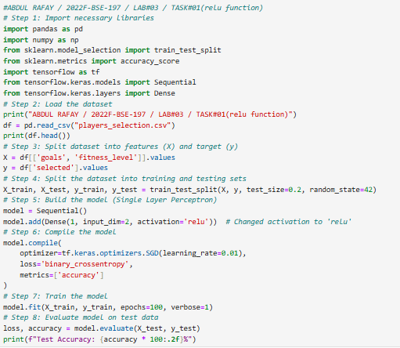

* **OUTPUT FOR RELU:**

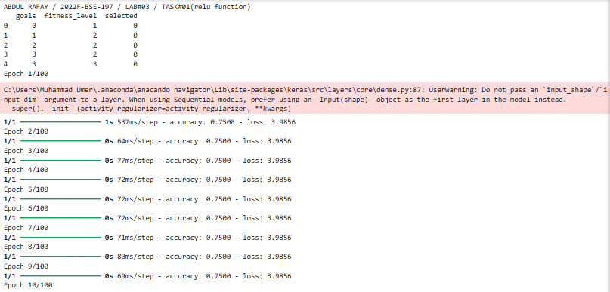

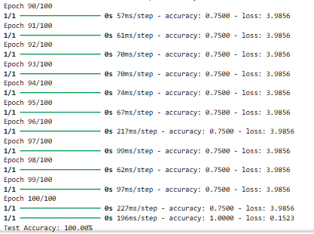

* **CODE FOR SIGMOID:**

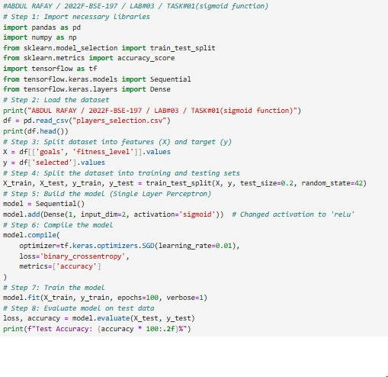

* **OUTPUT FOR SIGMOID:**

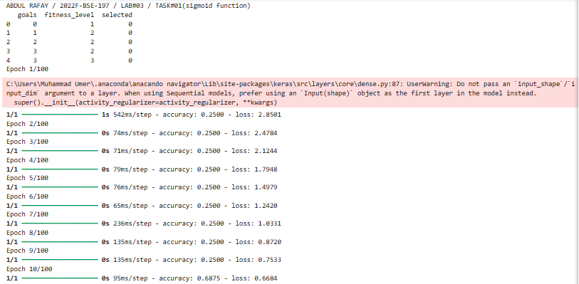

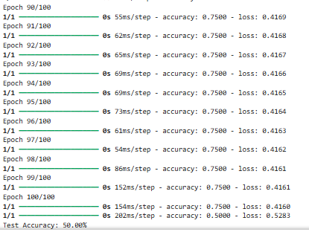

**TASK 2: ADD ONE MORE HIDDEN LAYER**

Understand how hidden layers increase the model’s learning power

* **CODE:**

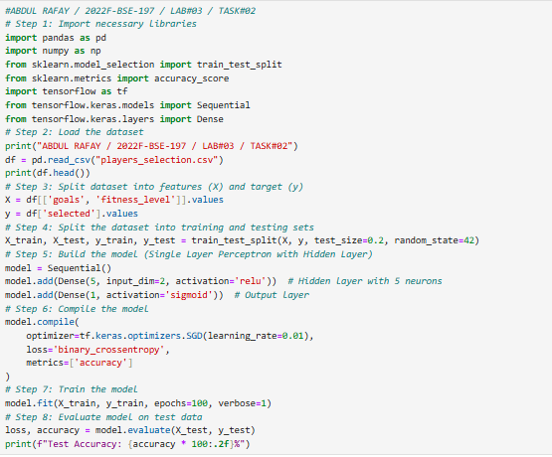

* **OUTPUT:**

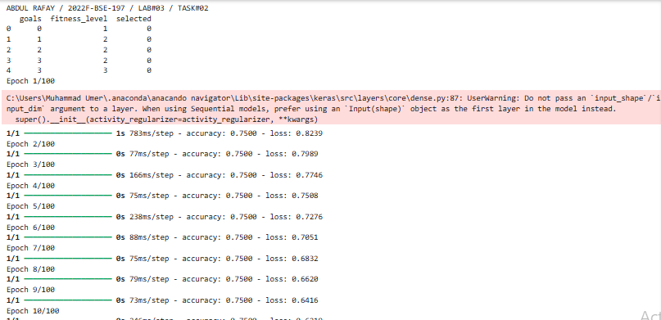

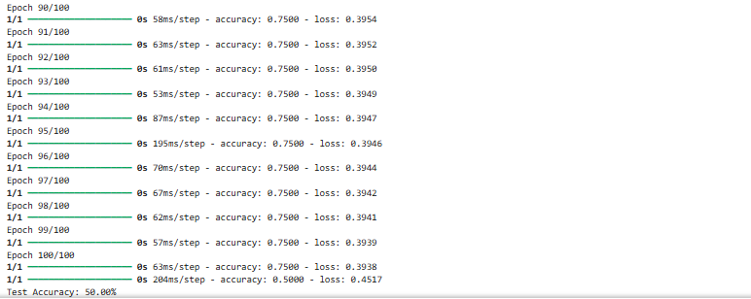

**TASK 3: ADD MORE NEURONS**

See how increasing neurons changes learning capacity.

* **CODE:**

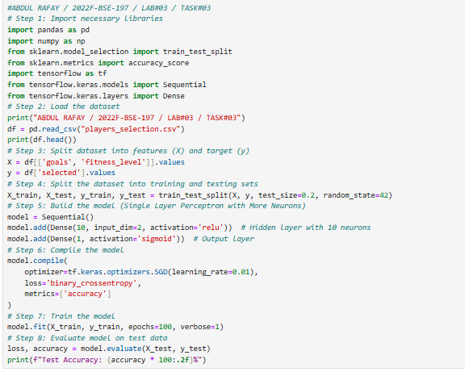

* **OUTPUT:**

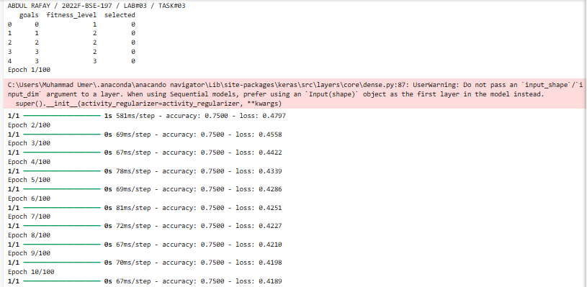

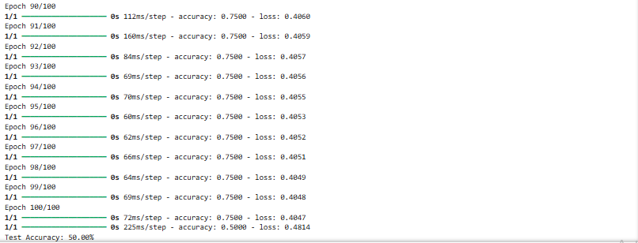

**TASK 4: COMPARE LOSS AND ACCURACY**

After each task:

* Print training accuracy.
* Print model predictions on test data.
* Observe and compare changes.
* **CODE:**

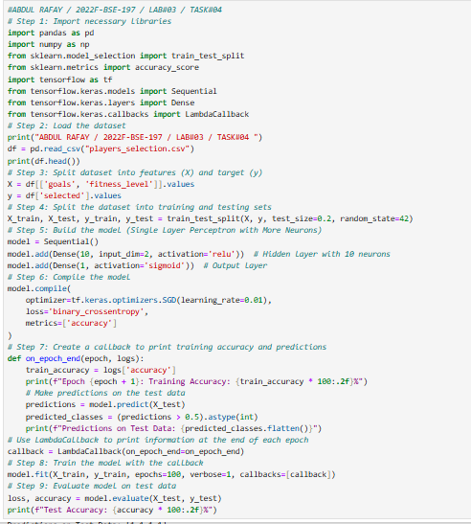

* **OUTPUT:**

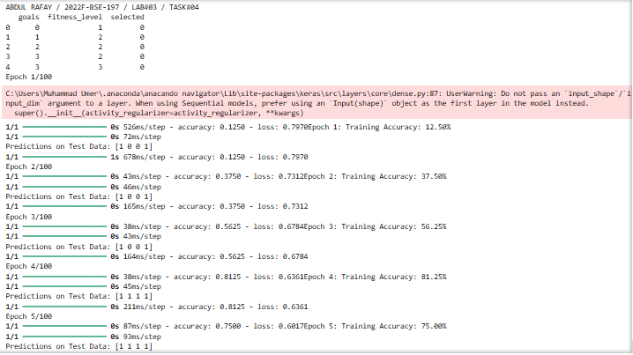

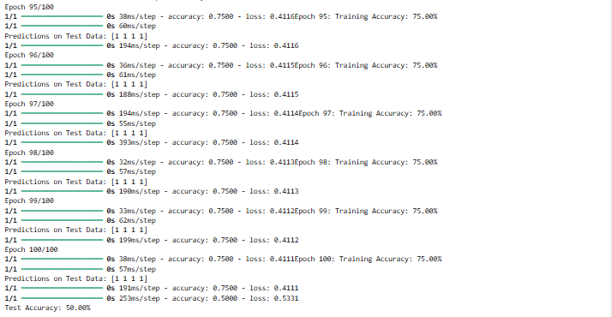

* **GITHUB UPLOAD:**
* **KAGGLE UPLOAD:**